Bryan Greener

Chad Hirsch

Jason Gunderson

2017-02-01 Workshop

2.125

a) 3388

b)

Full-time Part-time

15-19 0.20673664 0.02373688

20-24 0.31962412 0.07102758

25-34 0.10391750 0.10367342

35 + 0.04649744 0.12478643

c)

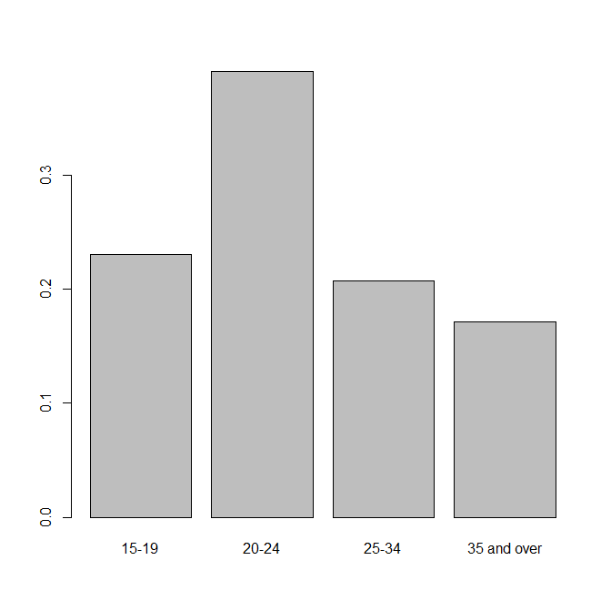

d)

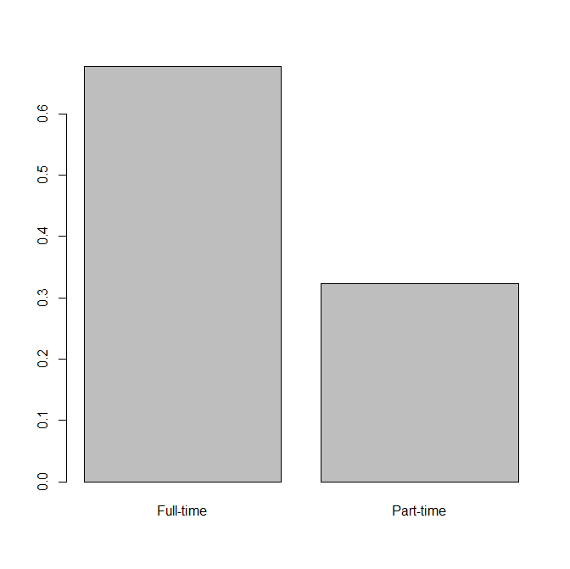

2.126

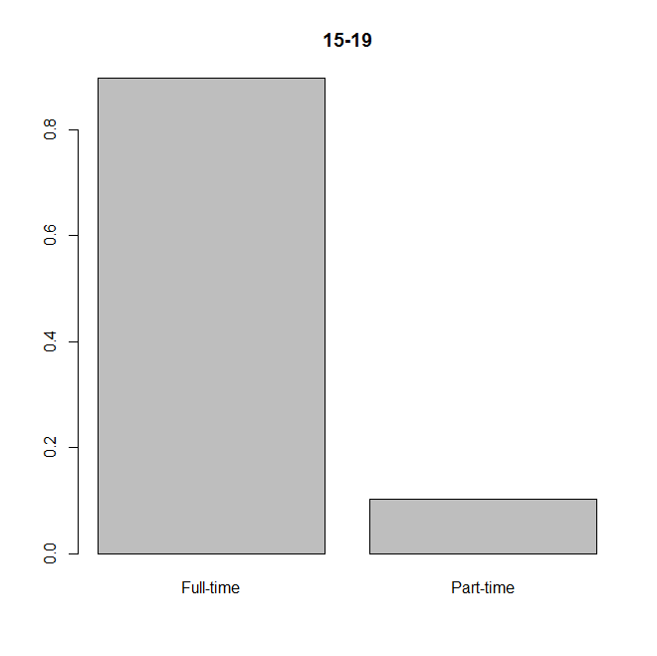



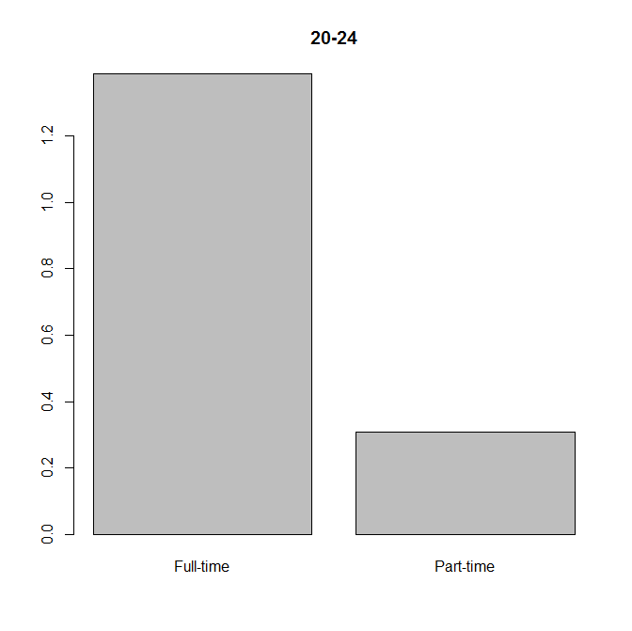

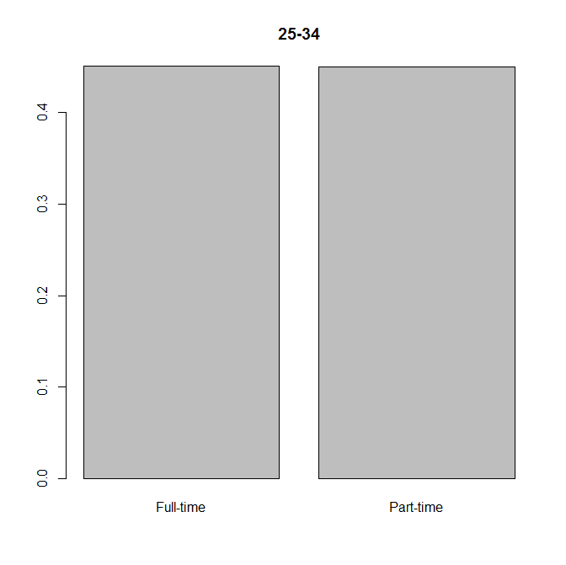

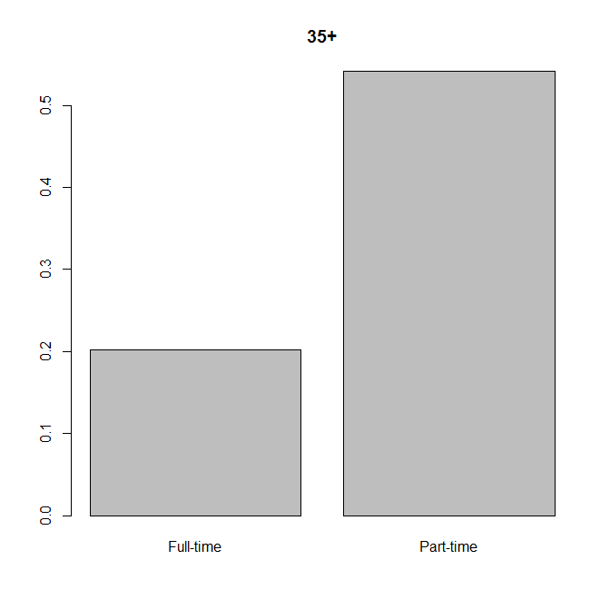

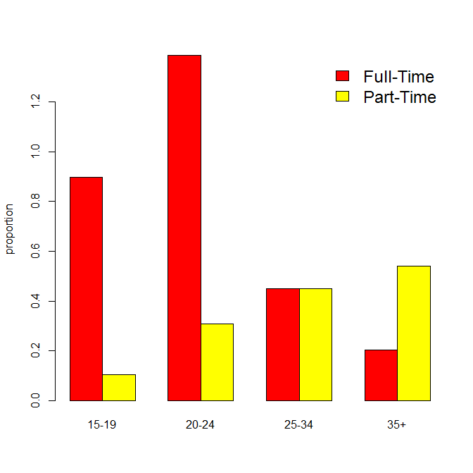

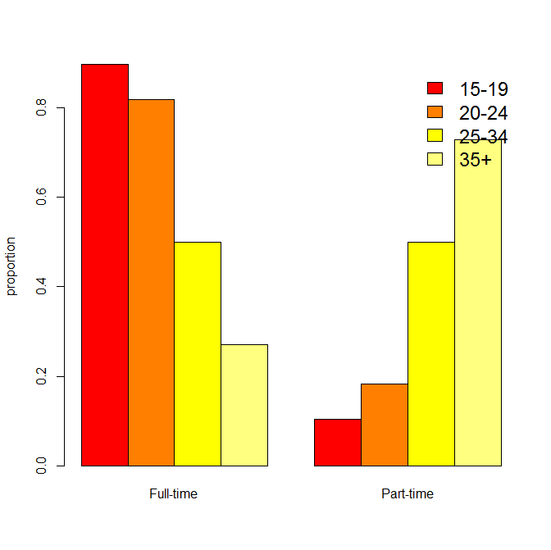

Summary

The first of the two colored charts is helpful for showing an obvious difference in enrollment between people of the same age. The second chart shows a trend where as people get older they move further and further away from being full time.

CODE BELOW:

# create array from data

data=c(3388,389,5238,1164,1703,1699,762,2045)

# change array into matrix then display end result

datamatrix=matrix(data,nrow=4,ncol=2,byrow=TRUE)

colnames(datamatrix)=c('Full-time','Part-time')

rownames(datamatrix)=c('15-19','20-24','25-34','35 and over')

datamatrix

# part a

# displaying value from matrix

datamatrix[1,1]

# part b

row1=sum(datamatrix[1,])

row2=sum(datamatrix[2,])

row3=sum(datamatrix[3,])

row4=sum(datamatrix[4,])

col1=sum(datamatrix[,1])

col2=sum(datamatrix[,2])

# generate and display joint distribution

total=sum(data)

prop.joint=datamatrix/total

prop.joint

# part c and d

# generate and display marginal distribution for rows and columns

prop.margin.row=c(row1/total,row2/total,row3/total,row4/total)

names(prop.margin.row)=c('15-19','20-24','25-34','35 and over')

prop.margin.col=c(col1/total,col2/total)

names(prop.margin.col)=c('Full-time','Part-time')

barplot(prop.margin.row)

x11()

barplot(prop.margin.col)

# 2.126

# generate conditional distribution

prop1=datamatrix[1,]/row1

prop2=datamatrix[2,]/row1

prop3=datamatrix[3,]/row1

prop4=datamatrix[4,]/row1

names(prop1)=c('Full-time','Part-time')

names(prop2)=c('Full-time','Part-time')

names(prop3)=c('Full-time','Part-time')

names(prop4)=c('Full-time','Part-time')

x11()

barplot(prop1,main="15-19")

x11()

barplot(prop2,main="20-24")

x11()

barplot(prop3,main="25-34")

x11()

barplot(prop4,main="35+")

table=cbind(prop1,prop2,prop3,prop4)

colnames(table)=c('15-19','20-24','25-34','35+')

x11()

barplot(table,beside=TRUE,col=heat.colors(2),ylab="proportion")

legend("topright",c('Full-Time','Part-Time'),cex=1.5,bty="n",fill=heat.colors(2));

prop.table(datamatrix)

table1=prop.table(datamatrix,margin=1)

table2=prop.table(datamatrix,margin=2)

x11()

barplot(table1,beside=TRUE,col=heat.colors(4),ylab="proportion")

legend("topright",c('15-19','20-24','25-34','35+'),cex=1.5,bty="n",fill=heat.colors(4));